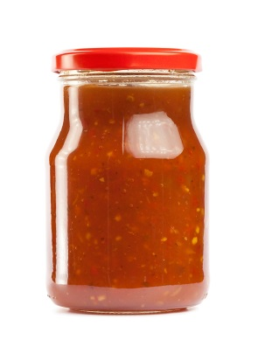
Black Bean and Corn Salsa

pH, Buffering Capacity, and Measuring pH Lab
Table of Contents: Records
Page Number | Document
1  2 | Product Formulation  pH Record

